Lab: Neo4j graph Algorithms

Do the following through Neo4J’s online sandbox at : https://neo4j.com/sandbox-v2/
You will need to sign up first. Click Start Now

Select a blank sandbox

Pathfinding Algorithms
Pathfinding algorithms explore routes between nodes, starting at one node and traversing through relationships until the destination has been reached. These algorithms are used to identify optimal routes through a graph for uses such as logistics planning, least cost call or IP routing, and gaming simulation.

Specifically, the pathfinding algorithm we’ll cover are:
• Shortest Path

Example Data: The Transport Graph
All connected data contains paths between nodes, which is why search and pathfinding are the starting points for graph analytics. Transportation datasets illustrate these relationships in an intuitive and accessible way. The examples in this section run against a graph containing a subset of the European road network.
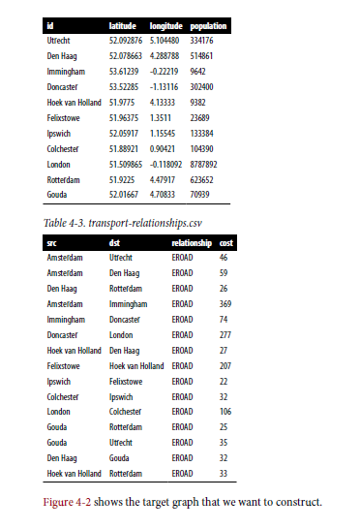

For simplicity we consider the graph to be undirected because most roads between cities are bidirectional. We’d get slightly different results if we evaluated the graph as directed because of the small number of one-way streets, but the overall approach remains similar. However Neo4j operate on directed graphs. In cases like this where we want to work with undirected graphs (e.g., bidirectional roads), there is an easy way to accomplish that:

• For Neo4j, we’ll create a single relationship and then ignore the relationship direction when we run the algorithms.

Having understood those little modeling workarounds, we can now get on with loading graphs into Neo4j from the example CSV files.

Importing the Data into Neo4j

We’ll start by loading the nodes:

WITH "https://github.com/neo4j-graph-analytics/book/raw/master/data/" AS base
WITH base + "transport-nodes.csv" AS uri
LOAD CSV WITH HEADERS FROM uri AS row
MERGE (place:Place {id:row.id})
SET place.latitude = toFloat(row.latitude),
place.longitude = toFloat(row.latitude),
place.population = toInteger(row.population)
And now the relationships:

WITH "https://github.com/neo4j-graph-analytics/book/raw/master/data/" AS base
WITH base + "transport-relationships.csv" AS uri
LOAD CSV WITH HEADERS FROM uri AS row
MATCH (origin:Place {id: row.src})
MATCH (destination:Place {id: row.dst})
MERGE (origin)-[:EROAD {distance: toInteger(row.cost)}]->(destination)

Although we’re storing directed relationships, we’ll ignore the direction when we execute algorithms later.

Shortest Path
The Shortest Path algorithm calculates the shortest (weighted) path between a pair of nodes. It’s useful for user interactions and dynamic workflows because it works in real time.

When Should I Use Shortest Path?
Use Shortest Path to find optimal routes between a pair of nodes, based on either the number of hops or any weighted relationship value. For example, it can provide realtime answers about degrees of separation, the shortest distance between points, or the least expensive route.

You can also use this algorithm to simply explore the connections between particular nodes.

Example use cases include:
• Finding directions between locations. Web-mapping tools such as Google Maps use the Shortest Path algorithm, or a close variant, to provide driving directions.

Finding the degrees of separation between people in social networks. For example, when you view someone’s profile on LinkedIn, it will indicate how many people separate you in the graph, as well as listing your mutual connections.

• Finding the number of degrees of separation between an actor and Kevin Bacon based on the movies they’ve appeared in (the Bacon Number). An example of this can be seen on the Oracle of Bacon website.

Shortest Path with Neo4j
The Neo4j Graph Algorithms library has a built-in procedure that we can use to compute both unweighted and weighted shortest paths. Let’s first learn how to compute unweighted shortest paths.

All of Neo4j’s Shortest Path algorithms assume that the underlying graph is undirected. You can override this by passing in the parameter direction: "OUTGOING" or direction: "INCOMING".

To have Neo4j’s Shortest Path algorithm ignore weights we need to pass null as the third parameter to the procedure, which indicates that we don’t want to consider a weight property when executing the algorithm. The algorithm will then assume a default weight of 1.0 for each relationship:

MATCH (source:Place {id: "Amsterdam"}),
(destination:Place {id: "London"})
CALL algo.shortestPath.stream(source, destination, null)
YIELD nodeId, cost
RETURN algo.getNodeById(nodeId).id AS place, cost
This query returns the following output:
place cost
Amsterdam 0.0
Immingham 1.0
Doncaster 2.0
London 3.0
Here the cost is the cumulative total for relationships (or hops).
Choosing a route with the fewest number of nodes visited might be very useful in situations such as subway systems, where less stops are highly desirable. However, in a driving scenario, we’re probably more interested in the total cost using the shortest weighted path.

Shortest Path (Weighted) with Neo4j
We can execute the Weighted Shortest Path algorithm to find the shortest path between Amsterdam and London like this:

MATCH (source:Place {id: "Amsterdam"}),
(destination:Place {id: "London"})
CALL algo.shortestPath.stream(source, destination, "distance")
YIELD nodeId, cost
RETURN algo.getNodeById(nodeId).id AS place, cost

The parameters passed to this algorithm are:
Source The node where our shortest path search begins
Destination The node where our shortest path ends
Distance The name of the relationship property that indicates the cost of traversing between a pair of nodes

The cost is the number of kilometers between two locations. The query returns the following result:
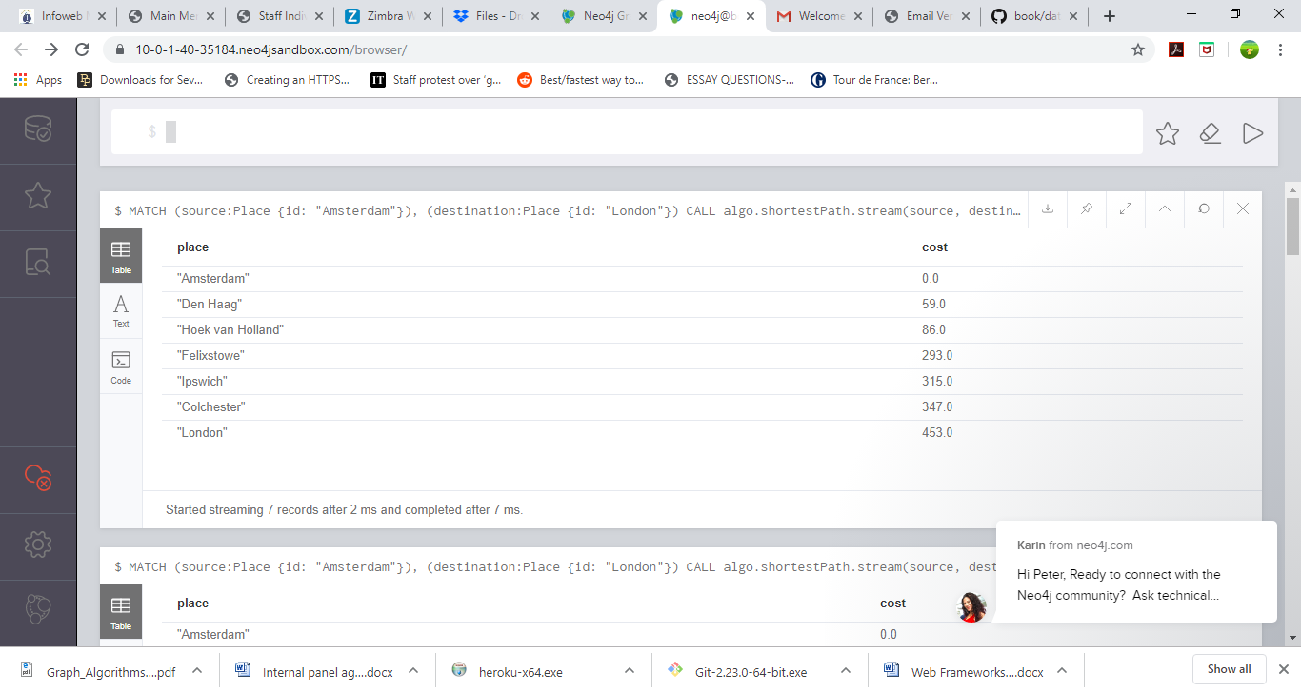
The quickest route takes us via Den Haag, Hoek van Holland, Felixstowe, Ipswich, and Colchester! The cost shown is the cumulative total as we progress through the cities. First we go from Amsterdam to Den Haag, at a cost of 59. Then we go from Den Haag to Hoek van Holland, at a cumulative cost of 86—and so on. Finally, we arrive in London, from Colchester, for a total cost of 453 km.

Remember that the unweighted shortest path had a total cost of 720 km, so we’ve been able to save 267 km by taking weights into account when computing the shortest path.

Centrality Algorithms
Centrality algorithms are used to understand the roles of particular nodes in a graph and their impact on that network. They’re useful because they identify the most important nodes and help us understand group dynamics such as credibility, accessibility, the speed at which things spread, and bridges between groups.

Although many of these algorithms were invented for social network analysis, they have since found uses in a variety of industries and fields.

Centrality Algorithms include:
• Degree Centrality as a baseline metric of connectedness
• Closeness Centrality for measuring how central a node is to the group
• Betweenness Centrality for finding control points
• PageRank for understanding the overall influence

Different centrality algorithms can produce significantly different results based on what they were created to measure. When you see suboptimal answers, it’s best to check the algorithm you’ve used is aligned to its intended purpose.

Figure 5-1. Representative centrality algorithms and the types of questions they answer
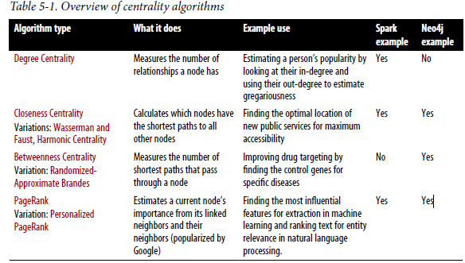
Example Graph Data: The Social Graph
Centrality algorithms are relevant to all graphs, but social networks provide a very relatable way to think about dynamic influence and the flow of information. The examples in this chapter are run against a small Twitter-like graph.

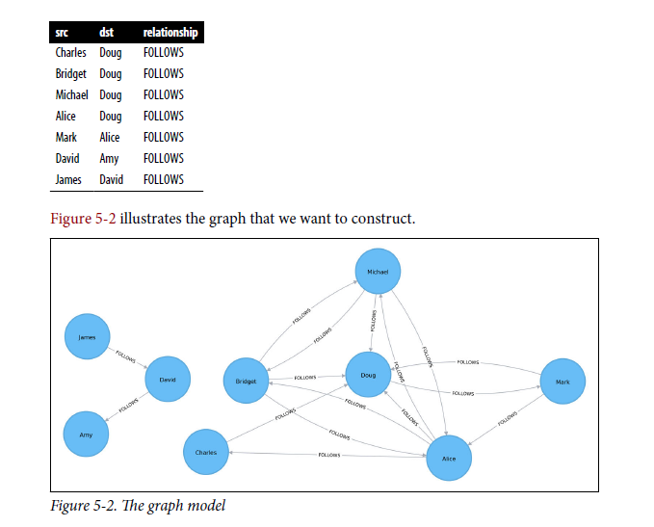
We have one larger set of users with connections between them and a smaller set with
no connections to that larger group. Let’s create graphs in Spark and Neo4j based on the contents of those CSV files.

Importing the Data into Neo4j
Next, we’ll load the data for Neo4j. The following query imports nodes:

WITH "https://github.com/neo4j-graph-analytics/book/raw/master/data/" AS base
WITH base + "social-nodes.csv" AS uri
LOAD CSV WITH HEADERS FROM uri AS row
MERGE (:User {id: row.id})

And this query imports relationships:

WITH "https://github.com/neo4j-graph-analytics/book/raw/master/data/" AS base
WITH base + "social-relationships.csv" AS uri
LOAD CSV WITH HEADERS FROM uri AS row
MATCH (source:User {id: row.src})
MATCH (destination:User {id: row.dst})
MERGE (source)-[:FOLLOWS]->(destination)

Closeness Centrality with Neo4j

Neo4j’s implementation of Closeness Centrality uses the following formula:
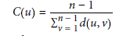where:
• u is a node.
• n is the number of nodes in the same component (subgraph or group) as u.
• d(u,v) is the shortest-path distance between another node v and u.

A call to the following procedure will calculate the closeness centrality for each of the nodes in our graph:

CALL algo.closeness.stream("User", "FOLLOWS")
YIELD nodeId, centrality
RETURN algo.getNodeById(nodeId).id, centrality
ORDER BY centrality DESC

Running this procedure gives the following output:
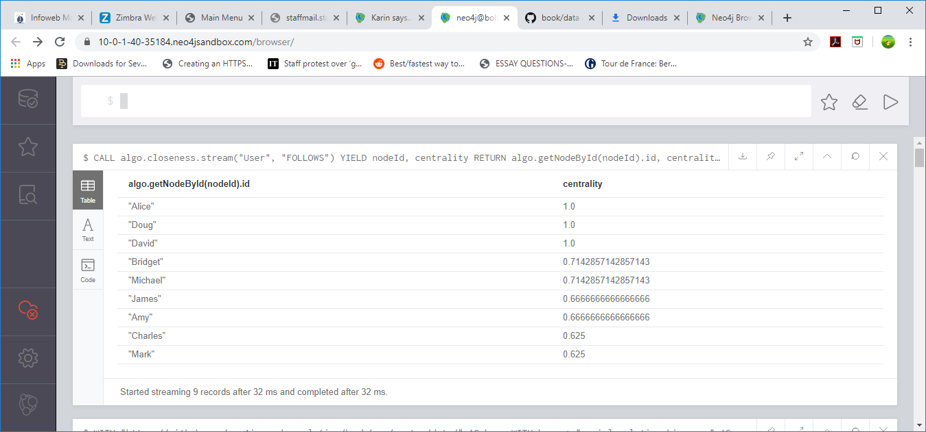
the score represents their closeness to others within their subgraph but not the entire graph.

Betweenness Centrality
Sometimes the most important cog in the system is not the one with the most overt power or the highest status. Sometimes it’s the middlemen that connect groups or the brokers who the most control over resources or the flow of information.

Betweenness Centrality is a way of detecting the amount of influence a node has over the flow of information or resources in a graph. It is typically used to find nodes that serve as a
bridge from one part of a graph to another.

Calculating betweenness centrality
The betweenness centrality of a node is calculated by adding the results of the following
formula for all shortest paths:
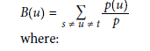
• u is a node.
• p is the total number of shortest paths between nodes s and t.
p(u) is the number of shortest paths between nodes s and t that pass through
node u.

When Should I Use Betweenness Centrality?
Betweenness Centrality applies to a wide range of problems in real-world networks. We use it to find bottlenecks, control points, and vulnerabilities.

Example use cases include:
- Identifying influencers in various organizations.
- Uncovering key transfer points in networks such as electrical grids.
- Helping microbloggers spread their reach on Twitter, with a recommendation engine for targeting influencers.

Betweenness Centrality with Neo4j

CALL algo.betweenness.stream("User", "FOLLOWS")
YIELD nodeId, centrality
RETURN algo.getNodeById(nodeId).id AS user, centrality
ORDER BY centrality DESC

Running this procedure gives the following result:
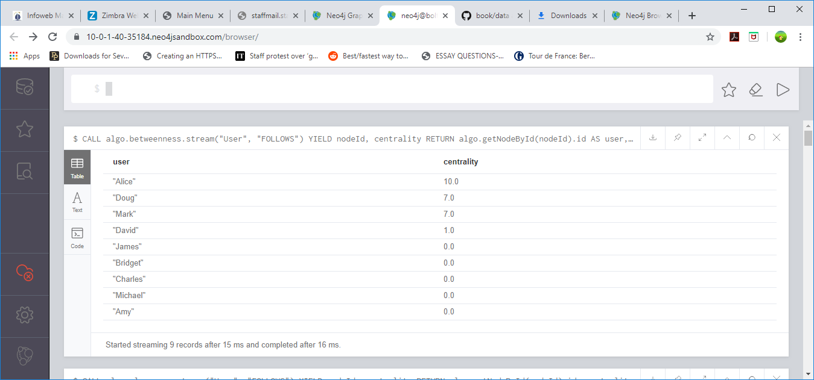

As we can see in Figure 5-9, Alice is the main broker in this network, but Mark and Doug aren’t far behind. In the smaller subgraph all shortest paths go through David, so he is important for information flow among those nodes.

PageRank
PageRank is the best known of the centrality algorithms. It measures the transitive (or directional) influence of nodes. All the other centrality algorithms we discuss measure the direct influence of a node, whereas PageRank considers the influence of a node’s neighbors, and their neighbors.

For example, having a few very powerful friends can make you more influential than having a lot of less powerful friends.

PageRank is named after Google cofounder Larry Page, who created it to rank websites in Google’s search results. The basic assumption is that a page with more incoming and more influential incoming links is more likely a credible source. PageRank measures the number and quality of incoming relationships to a node to determine an estimation of how important that node is. Nodes with more sway over a network are presumed to have more incoming relationships from other influential nodes.

The PageRank Formula
PageRank is defined in the original Google paper as follows:
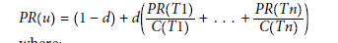
where:
• We assume that a page u has citations from pages T1 to Tn.
• d is a damping factor which is set between 0 and 1. It is usually set to 0.85. You
can think of this as the probability that a user will continue clicking. This helps
minimize rank sink, explained in the next section.
• 1-d is the probability that a node is reached directly without following any relationships.
• C(Tn) is defined as the out-degree of a node T.

When Should I Use PageRank?
PageRank is now used in many domains outside web indexing. Use this algorithm whenever you’re looking for broad influence over a network. For instance, if you’re looking to target a gene that has the highest overall impact to a biological function, it may not be the most connected one. It may, in fact, be the gene with the most relationships with other, more significant functions.

Example use cases include:
• Presenting users with recommendations of other accounts that they may wish to
follow (Twitter uses Personalized PageRank for this).
• Predicting traffic flow and human movement in public spaces or streets.
• As part of anomaly and fraud detection systems in the healthcare and insurance
industries.

PageRank with Neo4j
We can also run PageRank in Neo4j. A call to the following procedure will calculate
the PageRank for each of the nodes in our graph:

CALL algo.pageRank.stream('User', 'FOLLOWS', {iterations:20, dampingFactor:0.85})
YIELD nodeId, score
RETURN algo.getNodeById(nodeId).id AS page, score
ORDER BY score DESC

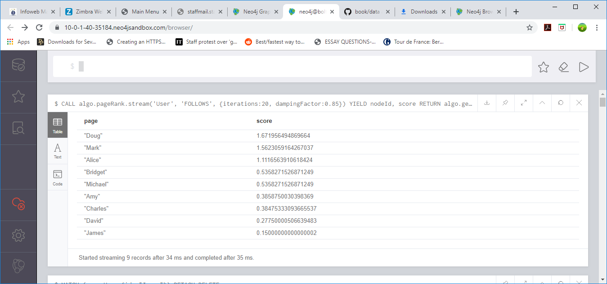

Doug is the most influential user, and Mark follows closely after as the only user that Doug follows. We can see the importance of the nodes relative to each other in Figure 5-13.

Community Detection Algorithms
Community formation is common in all types of networks, and identifying them is essential for evaluating group behavior and emergent phenomena. The general principle in finding communities is that its members will have more relationships within the group than with nodes outside their group. Identifying these related sets reveals clusters of nodes, isolated groups, and network structure. This information helps infer similar behavior or preferences of peer groups, estimate resiliency, find nested relationships, and prepare data for other analyses.

Community Detection Algorithms include:
- Triangle Count and Clustering Coefficient for overall relationship density
- Strongly Connected Components and Connected Components for finding connected clusters
- Label Propagation for quickly inferring groups based on node labels
- Louvain Modularity for looking at grouping quality and hierarchies

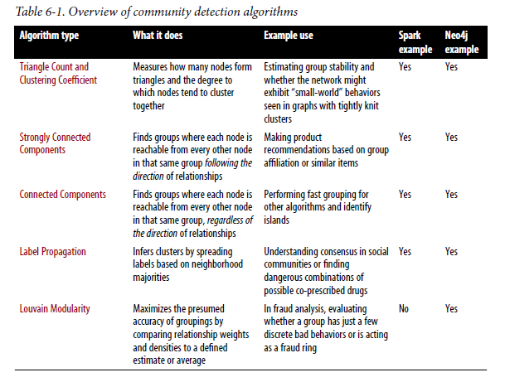

Example Graph Data: The Software Dependency Graph
Dependency graphs are particularly well suited for demonstrating the sometimes subtle differences between community detection algorithms because they tend to be more connected and hierarchical.

The examples below are run against a graph containing dependencies between Python libraries, although dependency graphs are used in various fields, from software to energy grids. This kind of software dependency graph is used by developers to keep track of transitive interdependencies and conflicts in software projects.

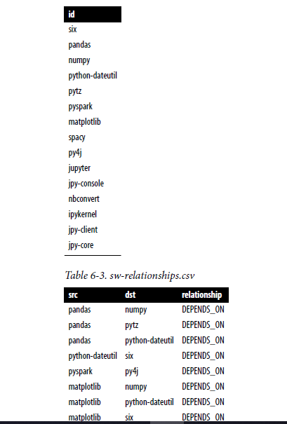
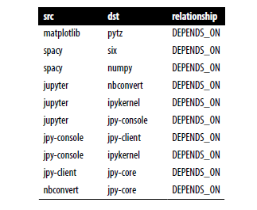

Figure 6-2 shows the graph that we want to construct. Looking at this graph, we see that there are three clusters of libraries. We can use visualizations on smaller datasets as a tool to help validate the clusters derived by community detection algorithms.

Importing the Data into Neo4j
Next we’ll do the same for Neo4j. The following query imports the nodes:

WITH "https://github.com/neo4j-graph-analytics/book/raw/master/data/" AS base
WITH base + "sw-nodes.csv" AS uri
LOAD CSV WITH HEADERS FROM uri AS row
MERGE (:Library {id: row.id})

And this imports the relationships:

WITH "https://github.com/neo4j-graph-analytics/book/raw/master/data/" AS base
WITH base + "sw-relationships.csv" AS uri
LOAD CSV WITH HEADERS FROM uri AS row
MATCH (source:Library {id: row.src})
MATCH (destination:Library {id: row.dst})
MERGE (source)-[:DEPENDS_ON]->(destination)

Strongly Connected Components
The Strongly Connected Components (SCC) algorithm is one of the earliest graph algorithms. SCC finds sets of connected nodes in a directed graph where each node is reachable in both directions from any other node in the same set.

When Should I Use Strongly Connected Components?
Use Strongly Connected Components as an early step in graph analysis to see how a graph is structured or to identify tight clusters that may warrant independent investigation.

A component that is strongly connected can be used to profile similar behaviour or inclinations in a group for applications such as recommendation engines.

Example use cases include:
- Finding the set of firms in which every member directly and/or indirectly owns
shares in every other member
- Computing the connectivity of different network configurations when measuring
routing performance in multihop wireless networks.
- Acting as the first step in many graph algorithms that work only on strongly connected graphs. In social networks we find many strongly connected groups.

Strongly Connected Components with Neo4j
Let’s run the same algorithm using Neo4j. Execute the following query to run the
algorithm:

CALL algo.scc.stream("Library", "DEPENDS_ON")
YIELD nodeId, partition
RETURN partition, collect(algo.getNodeById(nodeId)) AS libraries
ORDER BY size(libraries) DESC

The parameters passed to this algorithm are:
Library - The node label to load from the graph
DEPENDS_ON - The relationship type to load from the graph
This is the output we’ll see when we run the query:

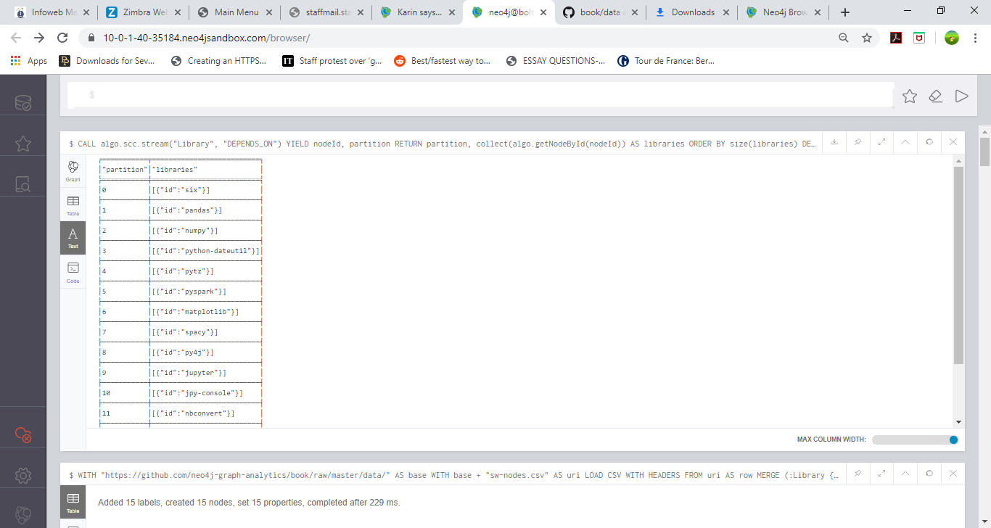
every node is in its own partition.

So far the algorithm has only revealed that our Python libraries are very well behaved, but let’s create a circular dependency in the graph to make things more interesting. This should mean that we’ll end up with some nodes in the same partition.

The following query adds an extra library that creates a circular dependency between py4j and pyspark:

MATCH (py4j:Library {id: "py4j"})
MATCH (pyspark:Library {id: "pyspark"})
MERGE (extra:Library {id: "extra"})
MERGE (py4j)-[:DEPENDS_ON]->(extra)
MERGE (extra)-[:DEPENDS_ON]->(pyspark)

Now if we run the SCC algorithm again we’ll see a slightly different result:

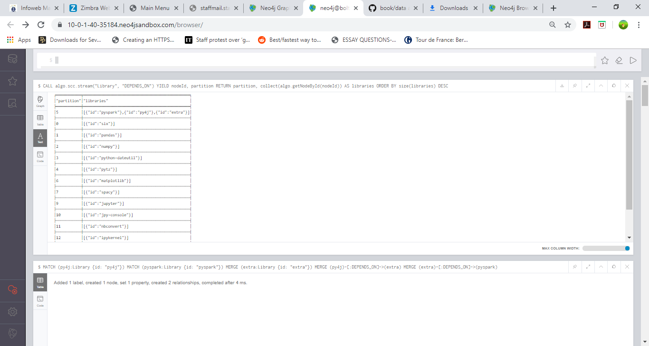

pyspark, py4j, and extra are all part of the same partition, and SCCs helped us find the circular dependency!

